 |  |  | Gym Realm Technology JSV
 |  |  | Pop Hariton 5 Street, 3rd floor, Varna, Bulgaria 9000
QUOTE |  |  | Contact
Customer: Tatiana Caloi |  |  |  +359 877 945 505
Customer: Tatiana Caloi |  |  |  Yana Georgieva
Customer: Tatiana Caloi |  |  |  yana@gymrealmmanager.com
Customer: Tatiana Caloi |  |  |  https://gymrealmmanager.com
Monthly Subscription |  | Premium PLUS custom
Sales management  POS module  Customer management with unlimited cloud storage  Membership management with more than 25 different settings  Classes management  Instructors’ management  Inventory management  Remote access  Training and support  User rights management with an unlimited amount of users  Database backup up to 30 days  Initial setup of the software and uploading of the application in Google Play Store and iOS App Store  Manager and staff training. |  | Reporting, more than 40 downloadable reports  Online schedules on your website  Digital waives  Online customer portal  Gift cards management  Automated online marketing  Custom corporate and retail discounts  Recurring payments management  Access control management  Invoicing  Staging environment  Online sales and payments  Loyalty program  KPI dashboard  Mobile Application custom branded  Technical support and information from 09:00 to 22:00. without a day off
Monthly subscription |  |  | 200 EUR 100 EUR
Monthly subscription Mobile App / Optional |  |  | 60 0 EUR
Configuration amp; Training |  |  | 1800 EUR
Configuration amp; Upload of Mobile App / Optional |  |  | 1000 EUR 0 EUR
Comments:
The monthly subscription is paid quarterly or annually with 10% discounts.
If you have any questions, please do not hesitate to contact us.
Support hours are available in Eastern European Time (EET; UTC+02:00)
No limitation on the number of waivers, customers, or workstations with installed software.

Access Control system

 | Amount | Units. price | Total
RFID Card with double-sided full-color printing | 500 | 1,65 EUR | 825,00 EUR
RFID Card with double-sided full-color printing | 1000 | 1,45 EUR | 1450,00 EUR

КАТ. N | NAME | PRICE | COUNT | TOTAL
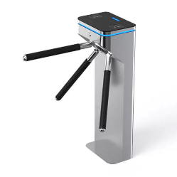  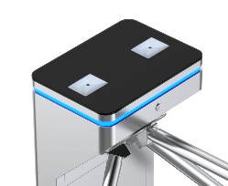 | Turnstile with LED indication and space for QR code readers | 1850,0 | 1 | 1850,0 EUR
QR / RFID reader  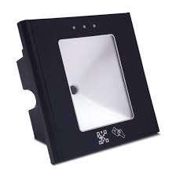 | 1D, QR code and 13.56 MHz RFID reader for access control | 135,0 | 2 | 270,0 EUR
 | Controller amp; UART convertor | 245,0 | 1 | 245,0 EUR
 | RFID card reader at the reception | 45,0 | 1 | 45,0 EUR
MNG AP  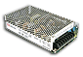 | Power supply, set:  Voltage 220 V AC/13.5 V DC, 3.5 A  Metal box with powder polymer coating  AD55-A Power Supply, 13.5 V DC, 4.0 A, AD Series, 1 Output, 1 Battery Output  Chandelier terminal with built-in fuse | 150,0 | 1 | 150,0 EUR
S bat 12/7  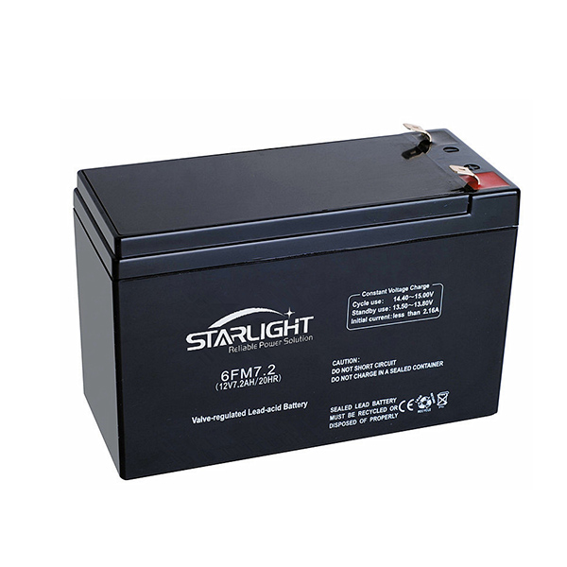 | Rechargeable battery, HD series – gel, 12/ 7.0 Ah, 70 x 101 x 77 mm, WxHxD: 50 x 95 x 151 mm | 30,0 | 1 | 30,0 EUR
 | Emergency exit button with recovery key | 25,0 | 1 | 25,0 EUR
 | TOTAL |  |  | 5230,0 EUR

