WAIVER AND RELEASE

I undersigned, Jorge Emilio Navarro Gonzalez, am aware that physical exercises and the use of the equipment and facilities owned by THE PLANET CLIMBING SA, might cause injuries, like all sports. However, all the equipment used by PLANET is certified for its specific use and the personnel trained to minimize the risks.

I agree to use the equipment made available by THE PLANET CLIMBING SA in a reasonable manner, with care and in accordance with the instructions provided.

I assume, by my signature, the risk of any bodily injury, loss or damage that my son (daughter) may suffer in the event of non-compliance with the rules of use and the guidelines provided by the instructors / coaches.

I undertake to relieve THE PLANET CLIMBING SA, as well as its employees, of all liability in the event of bodily injury, illness, loss or any other damage and sequel that may occur following the use of the facilities and equipment of THE PLANET CLIMBING SA or by participating in the activities of its centers.

I intend to make this document mandatory for my family, my successors, heirs, assignees or any other party acting on my behalf.

Any photographic material acquired during the activities is the property of THE PLANET CLIMBING SA. I consent to its use by THE PLANET CLIMBING SA, while respecting the legal provisions.
##LoyaltyProgram##

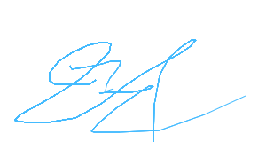
Date: 22.12.2025
Name Signatory : .............................…….............................…….............................…

