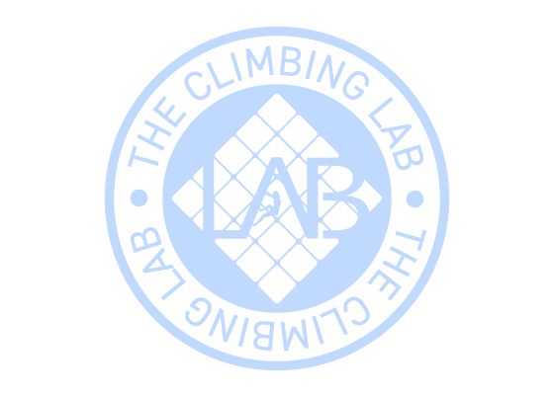
Expiration date:22/12/2026
From: Stefanie Schöppl
Code: 900498
To: Stefan Kober
Gift card 5 Climb Pass

