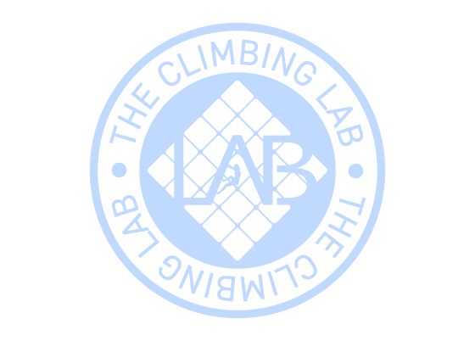
Expiration date:24/12/2026
From: Peter Russell
Code: 123608
To: Emily Smith
Gift card 5 Climb Pass

