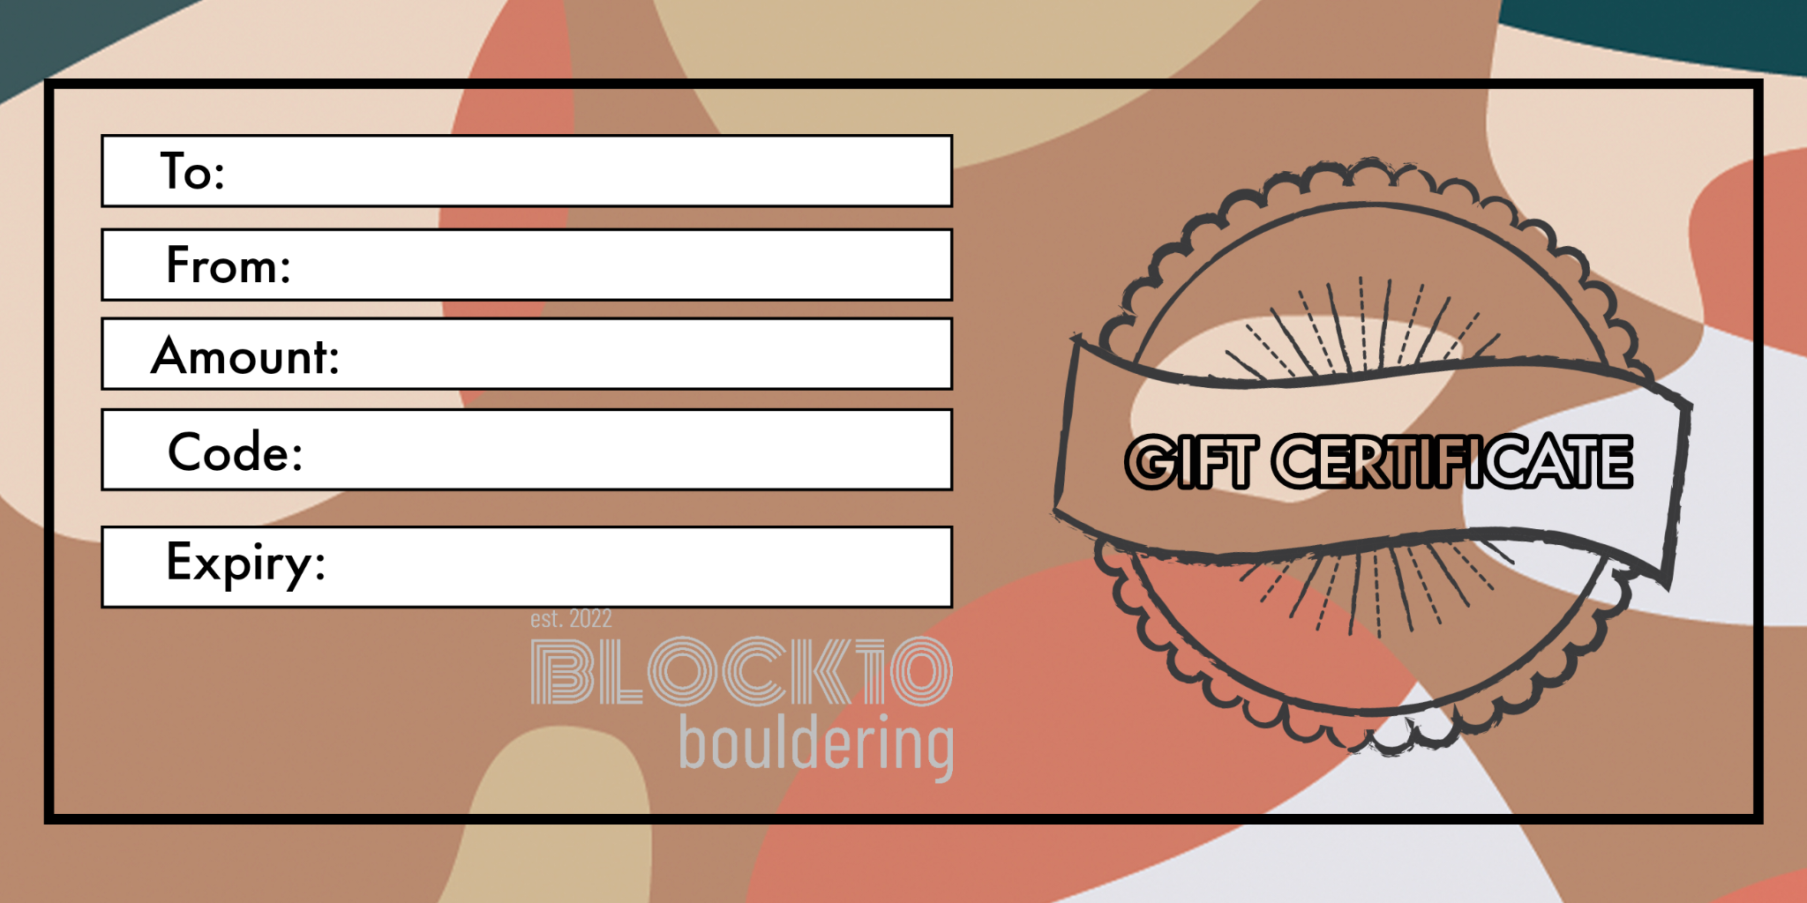
Gavin Christie
Adelle Christie
£10 Gift Card
711774
18/12/2026

