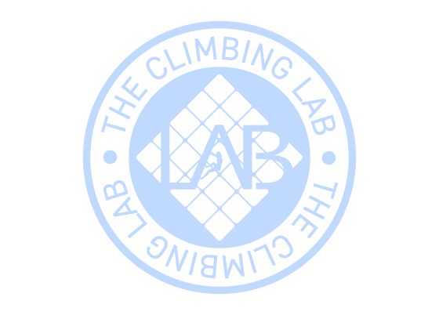
Expiration date:24/12/2026
From: Andrew Green
Code: 517190
To: Archie Leggett
Gift card 5 Climb Pass

