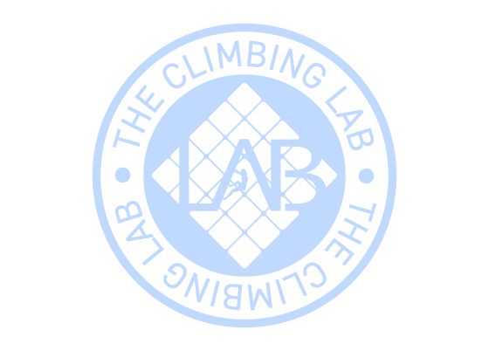
Expiration date:25/12/2026
From: Russell Holt
Code: 88671
To: Georgie Holt
Gift card 10 Climb Pass

