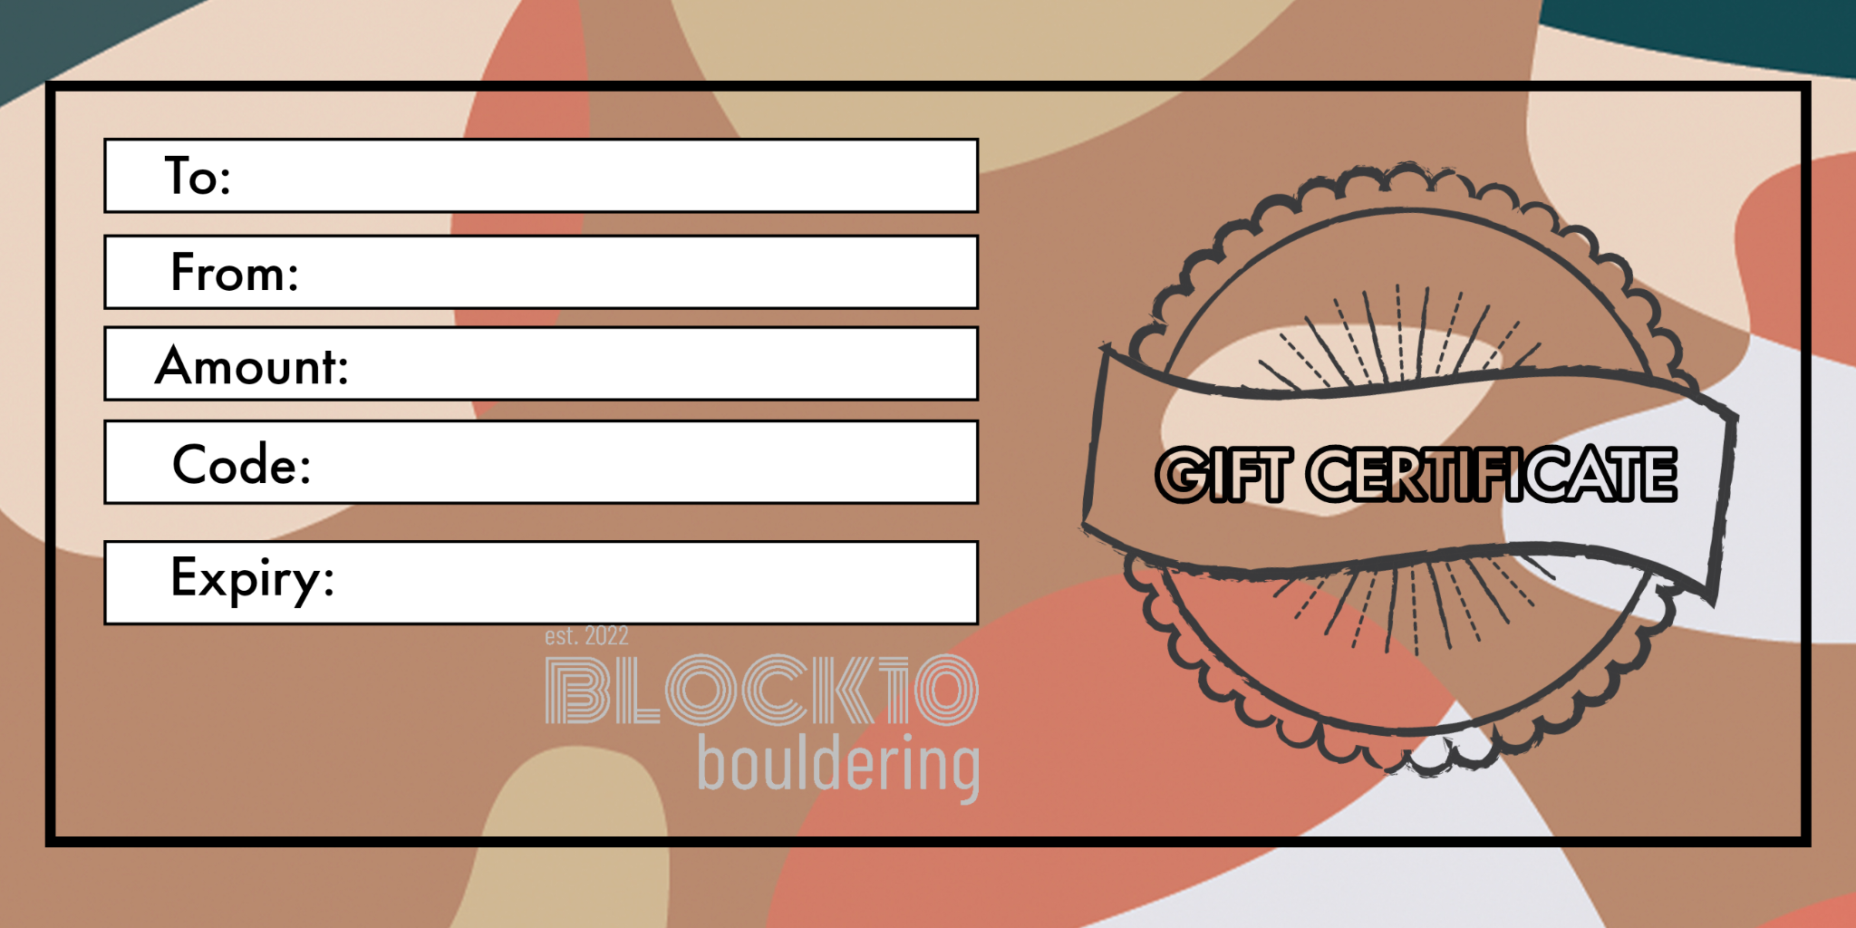
Niki Simeonov
Nikolay Simeonov
£1 Gift Test
981885
19/12/2026

