Lead Climbing Skills Declaration
By signing below, I confirm that I have been truthfully assessed and/or declare that I have the skills indicated.
TICK ALL THAT APPLY:

I know how to lead climb safely, including clipping quickdraws.

I know how to belay a lead climber safely with an approved device.

Belay Devices APPROVED at Rock Island
- Tubular belay devices (e.g. Black Diamond ATC, Petzl Verso, Edelrid MegaJul, Mammut Smart)
- Assisted-braking devices (e.g. Petzl GriGri, Edelrid GigaJul, Mammut Smart 2.0, Black Diamond Pilot)
Belay Devices NOT APPROVED at Rock Island
- Figure 8 devices

I understand that misrepresentation of my skills may result in loss of climbing privileges at Rock Island and that unsafe behavior may lead to injury or death.

Personal Information
- Full Name Akhil Hari
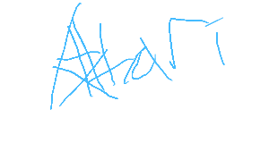
- Email: akhilh397@gmail.com

Participant’s Signature ____________________________
Date / 08/12/2025

