LEAD CLIMB SAFETY COMPETENCY

I Stephanie Neoh and/or my child/minor
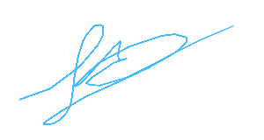
acknowledge that I/we have undertaken the Gravity Worx safety Assessment for lead climbing within the gym. As such I/we have a thorough understanding of the following
* Gravity Worx Centre Rules
* Proper use of auto belays and safety "Climber Above" drop down mats
* Proper use of Karabiners (including that I/we must have two karabiners clipped in opposing directions an all auto belay and top roped setups)
* proper ground sling length
* Proper communication
* buddy check prior to leaving ground
* Correct "5 step" belay method for top roped climbing
* Correct lowering method for all roped climbing
* Gravity Worx takes NO responsibility for the condition of my personal climbing equipment and that it is my responsibility to provide my own lead climbing equipment, except in situ quickdraws(Gravity Worx Centre Rules - Lead climbing rules)
* Proper use of in situ quickdraws (No back clipping or Z clipping allowed)
* Lead climbing is only performed with a climbing partner who is also an accredited Gravity Worx lead Climber
* Proper method for arresting a lead climber fall, and taking a lead fall
* I/we must obtain a lead climb pass on the day of climbing , and this will only be issued if staff member deems lead climbing is suitable with regards to other current activity within the gym, and may be limited to particular walls
* Gravity Worx lead climbing proficiency assessment in no way indicates my ability to climb outdoors, which requires skills of protection placement.
I/we have achieved the necessary skills to Lead Climb and Lead Belay, Top Rope climb and use the auto belays.
_____________________________ Date 24/03/2026
(Signature)

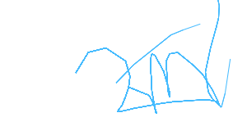
_____________________________ Melissa Santos Nova
Trained by (Signature) (Printed)

