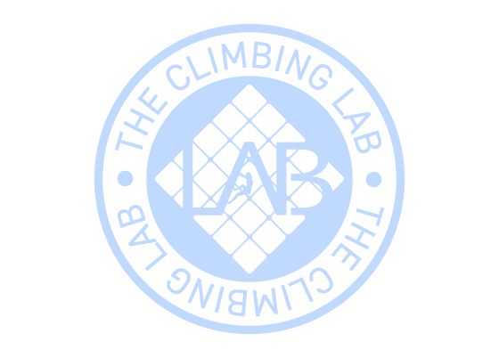
Expiration date:22/03/2027
From: Jae Ko
Code: 218921
To: Luke Sullivan
Gift card 10 Climb Pass

