AUTORISATION FOR ACTIVITY

I undersigned, Neha ##LastName##, hereby authorize the child I am responsible for, to participate in the activities and to use the equipment and facilities owned by THE PLANET CLIMBING SA, knowing that, as any sport, injuries might occur.
All the equipment used by PLANET is certified for its specific use and the personnel trained to minimize the risks.
In the case of the non-respect of directives given by the PLANET personnel, injury or accident might occur. In this case, any specific user (or guarantor person in case of minor user) is responsible for his/her actions.
Any photographic material acquired during the activities is the property of THE PLANET CLIMBING SA. I consent to its use by THE PLANET CLIMBING SA, while respecting the legal provisions.
X

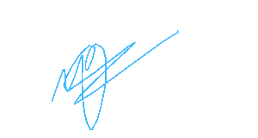
Date: 30.05.2026
Name Signatory : .............................…….............................…….............................…

Signature of adult member or of Parent or Guardian of member under the age of 18 years:

…………………………………………………

