TOP ROPED SAFETY COMPETENCY

I jahla ferguson and/or my child/minor
acknowledge that I/we have undertaken the Gravity Worx Safety Induction and am able to use the gym facilities unassisted, as well as having a thorough understanding of the following:
* Gravity Worx Centre Rules
* Proper use of Harness
* Proper use of karabiners (including that I must have two karabiners clipped into my harness before leaving the ground to climb, clipping direction must be opposed)
* Proper communication
* Proper ground sling length
* Proper use of auto belay systems and safety "Climber Above" drop down mats
* Buddy check of climbing partner prior to leaving ground on every climb
* Identification of potential hazards and how to move safely within the gym
* Correct "5 step" belaying method for top roped climbing
* Correct Lowering method for top roped climbing
* Gravity Worx takes NO responsibility for the condition of my personal climbing equipment that I provide
I have achieved the necessary skills to use the auto belays and the top roped setups
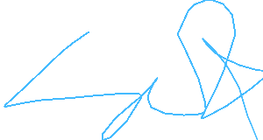
_____________________________ Date 13/05/2026
(Signature)

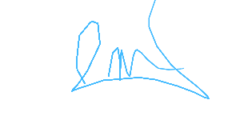
_____________________________ Liam Buchanan
Trained by (Signature) (Printed)

