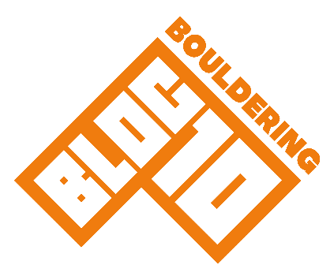

Acknowledgement of Risk Form
Bloc10 Aberdeen Centre

First Name: Syed Muhammad Talha |  | Last Name: Azam |  |  |  | Gender: Male
Date of Birth: 21/07/2006 | Telephone: +4407464797941 |  |  |  | Address: 32 Collieston Way, Bridge of Don, Aberdeen, UK Aberdeen, UK Ab228sl
Post Code: Ab228sl |  |  | Email: talhaazam166@gmail.com
Emergency Contact: Malahim Fatima |  |  |  | Emergency Telephone: +4407464797941
Syed Muhammad Talha Azam  Date of Birth: 17/05/2011 |  |  |  | Date of Birth:
Date of Birth: |  |  |  | Date of Birth:
Date of Birth: |  |  |  | Date of Birth:

Unsupervised climbing
Participation statement

“All climbing and bouldering activities have a risk of serious injury or death. Participants must be aware of and accept that even if they follow all good practice there may still be the risk of accident and injury. It is the responsibility of the participant to adhere to the conditions of use.”

It is important that you understand this document. There is inherent risk involved with climbing centres and associated activities. By signing this form, you are stating you understand that these risks cannot be completely removed. If you do not understand any of the terminology or content, ask a member of staff to clarify.

Conditions of use
General Safety

- Report to reception on each visit before you climb
- You must exercise care, common sense and self-preservation at all times
- Report any problems with the walls, equipment or other climbers' behaviour to a member of staff immediately. This is particularly important with broken or spinning holds
- Be aware of the other climbers around you and how your actions will affect them
- Never stand directly underneath someone who is climbing
- If you have children, you must keep them under control and supervise them directly at all times. Be close enough to affect or control the child’s behaviour at all times
- Please make yourself aware of the location of the fire exits in the building and fire assembly points

- As a user of this climbing wall, you must be aware of and accept the following:
Volumes on the walls are designed to enhance the quality of climbing but you must be aware of and accept that when climbing above them there is an additional risk of falling onto them
- Climbing beyond your capabilities on any wall is likely to result in a fall. Any fall may result in an injury despite the safety systems in place. You must make your own assessment of the risks whenever you climb
- Participants must understand that climbing while pregnant can increase the risk posed to mother and unborn child
- Participants must be aware and accept that climbing holds can spin or break
- You must do everything reasonable and practical to avoid endangering yourself or others
- You have to be aware of and adhere to the safety rules of the centre at all times
- Stand back from the climbing walls unless you are spotting a climber. Please empty your pockets and remove all jewellery before climbing

Bouldering

- Whenever possible, downclimb, or if this is not possible, use a controlled/planned jump
- It is your responsibility to ensure that you can climb down or land safely; don’t climb into a situation that you cannot safely get out of
- Never climb directly above or below another climber
- Top out (climb over the top) in designated areas only, if unsure, climb down
- Remove anything from pockets that could hurt you when landing - Always be aware of people climbing above and around you
Training area

- You use the training equipment at your own risk
- If you are unsure how to safely use any item, please ask a member of staff
THE SOFT MATTING DOES NOT REMOVE THE RISK OF INJURY. Injuries can still occur even after a controlled/planned jump but are more likely after an uncontrolled fall. You should always be doing your utmost to avoid the risk of uncontrolled falls. This includes paying attention to how you will land and always assessing the risk of each climb that you undertake.
Our Duty of Care

The conditions of use of the climbing centre are not intended to limit your enjoyment of the facilities; they are part of the duty of care that we, as operators, owe to you, the customer, by law. As such, they are not negotiable and if you are not prepared to abide by them then the staff may ask you to leave.
Your Duty of Care

You have a duty of care to act responsibly towards the other users of the centre, follow good practice and abide by the conditions of use of the centre. Statements of ‘Good Practice’ are posted around the centre adjacent to the relevant facilities. These describe the accepted methods of use of equipment and climbing areas.

Unsupervised Climbing

Before you can use the bouldering walls without supervision, you must be aware of the safe usage of bouldering and know how to use the bouldering walls safely. You are required to register to say that you know how to boulder and that you are prepared to abide by the rules and that you understand the risks involved in your participation. Anyone who is not competent to climb unsupervised must be supervised by a competent person.

Supervised Climbing

An adult who has registered at the centre, and proved competency, may supervise up to two novice climbers, as long as they are prepared to take full responsibility for the safety of those people.
Groups of three or more novices must only be supervised by an instructor holding the relevant valid Mountain Leader Training qualification and insurance or other relevant qualification.
All children in the centre must be supervised by an adult unless they have been assessed by the management and registered for unsupervised climbing.

Declarations

I certify that to the best of my knowledge, I do not suffer from a medical condition that might have the effect of making it more likely that I be involved in an accident that could result in injury to myself or others.
I also confirm that the above information is correct and if any information changes I will notify the centre.

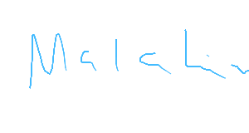
Date: 11/07/2026
Signature...................................................................

