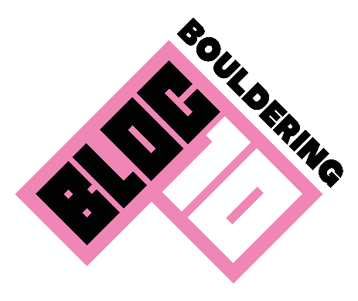

Acknowledgement of Risk Form for Climbing Outdoors
Bloc10 Aberdeen Centre

First Name: David |  | Last Name: Dang |  |  |  | Gender: Male
Date of Birth: 24/11/2006 | Telephone: +447305360769 |  |  |  | Address: 16 Auchlee Gardens, Portlethen, Aberdeen, UK Aberdeen, UK AB12 4AD
Post Code: AB12 4AD |  |  | Email: davidjasonlogan@icloud.com
Emergency Contact: David Dang |  |  |  | Emergency Telephone: +447305360769
Medical Condition: |  |  |  | Medical Condition Details: NONE

Please ensure that, before signing this consent form, you have previously signed the in-centre acknowledgment of risk form (waiver) for any participating parties.

Climbing Participation statement

“All climbing and bouldering activities have a risk of serious injury or death. Participants must be aware of and accept that even if they follow all good practice, there may still be the risk of accident and injury. It is the responsibility of the participant to adhere to the conditions of use.”

You must understand this document. There is inherent risk involved with climbing and associated activities. By signing this form, you acknowledge that these risks cannot be completely eliminated. If you do not understand any of the terminology or content, ask a member of staff to clarify.

General safety

- You must exercise care, common sense and self-preservation at all times
- Report any problems with the walls, equipment or other climbers' behaviour to a member of staff. - Be aware of the other climbers around you and how your actions will affect them
- Never stand directly underneath someone who is climbing. As a climber, you must be aware of and accept the following:
- Climbing beyond your capabilities on any wall is likely to result in a fall. Any fall may result in an injury despite the safety systems in place. You must make your own assessment of the risks whenever you climb - Participants must be aware and accept that climbing holds can spin or break
- You must do everything reasonable and practical to avoid endangering yourself or others - You have to be aware of and adhere to the safety rules provided by instructors at all times - Stand back from the climbing walls unless you are spotting a climber
- Please empty your pockets and remove all jewellery before climbing

Bouldering

- Whenever possible, downclimb, or if this is not possible, use a controlled/planned jump - It is your responsibility to ensure that you can climb down or land safely; don’t climb into a situation that you cannot safely get out of
- Never climb directly above or below another climber
- Top out (climb over the top) in designated areas only; if unsure, climb down
- Remove anything from pockets that could hurt you when landing
- Always be aware of people climbing above and around you

Bouldering Outdoors

- Bouldering outside poses additional risks to climbing in a designated climbing centre. Participants must therefore follow all instructions given by instructors
- Participants may only climb in areas agreed upon by instructors
- Unless given direct permission to do so, participants may not climb unless being spotted by an instructor.
- Participants must not climb in an area without appropriate safety matting below them. In an outdoor setting, portable bouldering mats are used. A climber must ensure they have the appropriate mats before climbing and ensure they land on the mat, and not off an edge, if jumping or falling - The climber must ensure they have a spotter when necessary to limit risk of missing the bouldering mat

THE SOFT MATTING DOES NOT REMOVE THE RISK OF INJURY. Injuries can still occur even after a controlled/planned jump but are more likely after an uncontrolled fall. You should always be doing your utmost to avoid the risk of uncontrolled falls. This includes paying attention to how you will land and always assessing the risk of each climb that you undertake.

☒I HAVE HAD SUFFICIENT OPPORTUNITY TO READ THIS ENTIRE DOCUMENT. I HAVE READ AND UNDERSTOOD IT, AND I AGREE TO BE BOUND BY ITS TERMS.

☒ I have previously signed the in-centre acknowledgment of risk form (waiver) for any participating parties.
☒I have read and understood all information provided, understand the additional risks involved in outdoor bouldering, and consent to participate in the described activities. If I have questions, I have asked the staff.
I consent to be included in photographs used for promotional content
☒I am over 18 years of age.
☒I understand there is a risk of injury involved.
☒I understand that failure to exercise due care could result in your injury or death.
☒I understand that the boulder matting does not remove the risk of injury.
☒I agree to abide by this document and the conditions of participation.
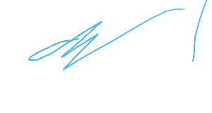
Date: 05/09/2026
Signature...................................................................

