Before using the gym I declare the following:

I declare that I have read, understood and fully accepted Arena Boulder's regulations
(https://www.arenaboulder.it/en/regulations/ )
I declare that I am of legal age.

I declare that I am fully aware of the risks associated with climbing, including, but not limited to, injuries such as fractures, abrasions, contusions and I understand that the mattresses at the gym do not eliminate the risk of injury.

I declare that I am in good health, that I do not suffer from acute/chronic illnesses or mental illnesses for which there are medical contraindications to using the climbing gym.

I declare that I have the ability to practice climbing and I release ARENA BOULDER SRLS as manager of the climbing gym, its employees, from liability in the event of non-exhaustive risks, when they occur due to overestimation of my climbing experience, physical preparation and ability, poor health, incorrect assessment of external factors.

I declare that I am aware and accept that the gym area is subject to video surveillance to ensure the safety of visitors.
I declare that I have read and accepted Arena’s Boulder’s Privacy Policy. (https://www.arenaboulder.it/en/privacy/ )

Gabriele Dellai
Date of birth: 18/11/2003 Phone number: +393927613704
e-mail gabriele.dellai@icloud.com

I agree to receive emails with news and events from gym.
X

I authorize Arena Boulder SRLS to publish images in which my face appears on social media and the gym website.

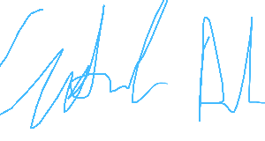
Date: 01/09/2026
Company ...................................................................

